**Git Assignment:**

Having two remote branches **main** & **develop**(default)

Cloning the repo to local.

Add a text file and push to develop branch.

Created a **feature** branch and made changes in the text file and pushed to **feature** branch.

Pull request created automatically and merged the changes from **feature** to **develop** successfully.

Created a new branch **release** from **develop**.

All the data in **develop** branch comes to **release** branch.

Raised PR from **release** to **main.**

Finally, main will have a stable production code.

**PR1:**

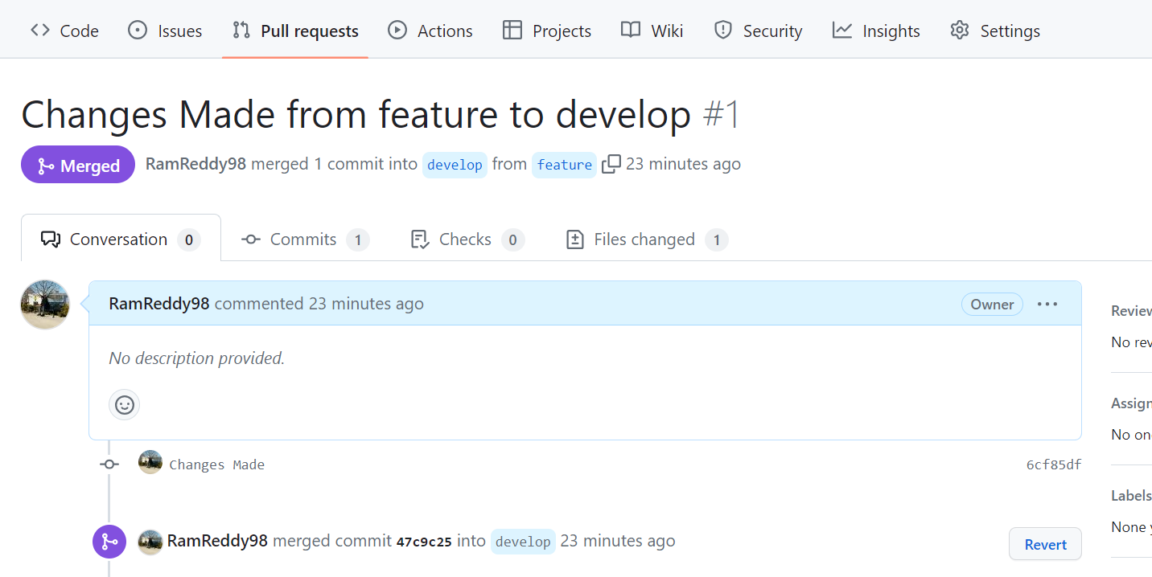

**PR2:**

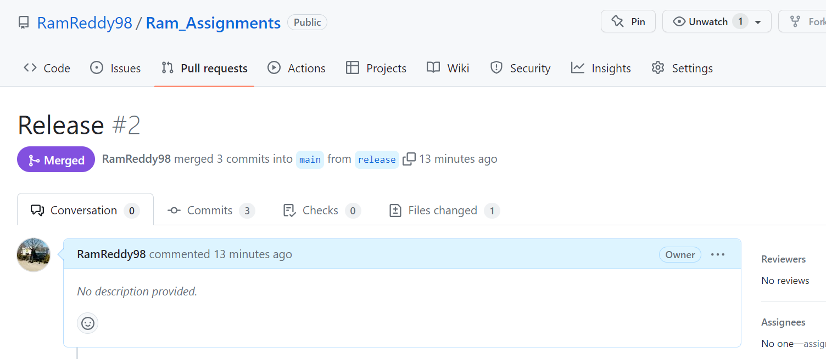

**Created VM in Azure and logged in:**

